CSA1509-Cloud computing and big data analytics
Experiment-7
Create a simple cloud software application for Learners Attendance System using any Cloud Service Provider to demonstrate SaaS include the necessary fields such as name of the learners, course, present, Absent, course attendance, OD request, grade, attendance percentage, etc.
Input:
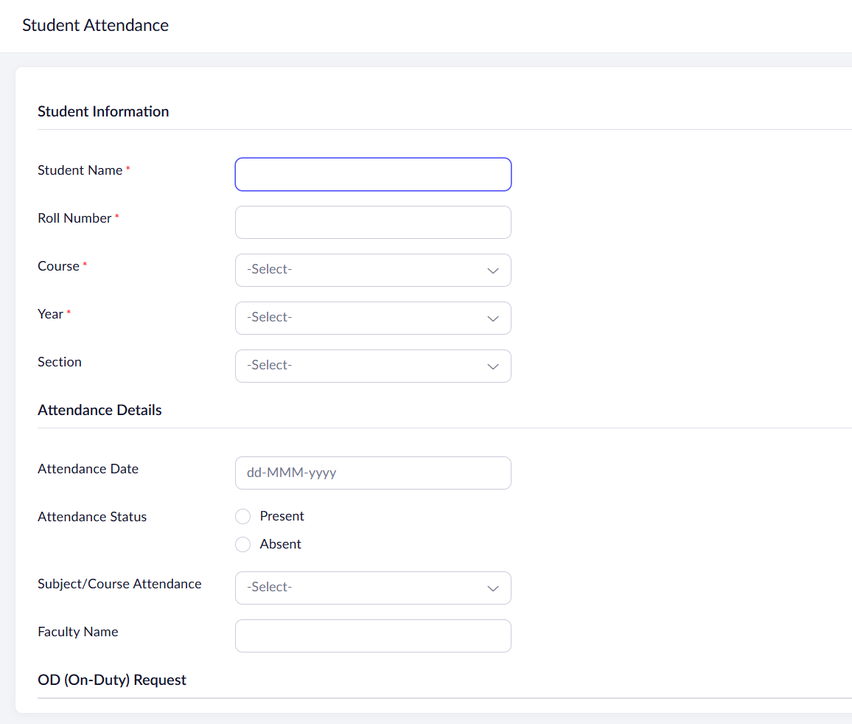
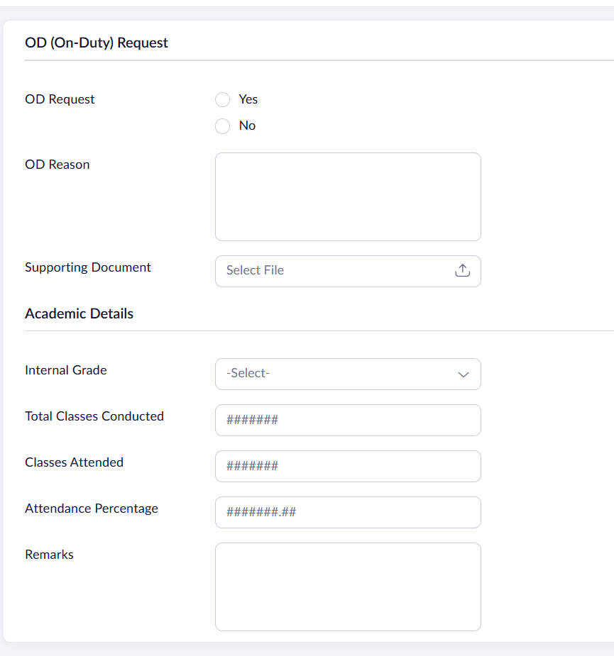

Output:
